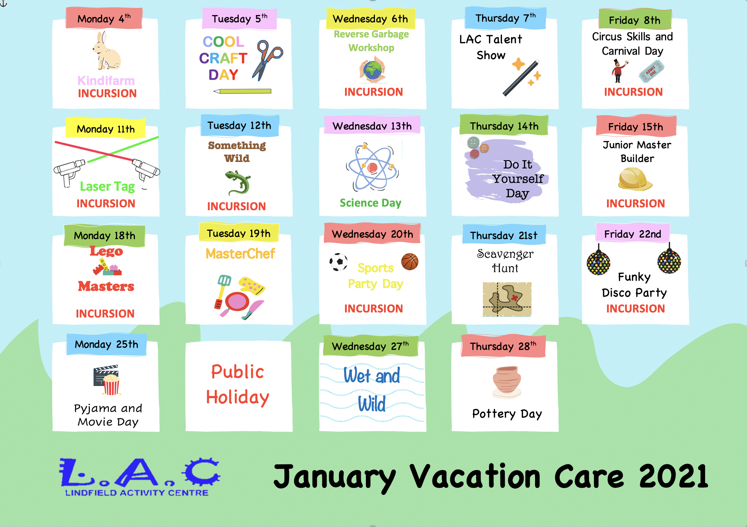

MORE INFO:
MONDAY 4TH – KINDIFARM INCURSION

Some very special furry friends will be joining us today in our very own Kindifarm! We will have the chance to not only hang out and play with the animals, but also develop our drawing and thinking skills by learning to draw animals in a fun way!

TUESDAY 5TH – COOL CRAFTS DAY

Today we have a jam packed day lined up full of epic wearable take home crafts such as tie dye and hat decorating. Come along and create some cool items to wear for the rest of the holidays!

WEDNESDAY 6TH – REVERSE GARBAGE INCURSION

Join us today for a creative workshop from our friends at Reverse Garbage! We will learn to reduce our impact on our natural environment and take home some goodies to further our understanding of the importance of upcycling.

THURSDAY 7TH – LAC TALENT SHOW

Take the stage today and be a part of our LAC Talent Show! Prepare and perform your best act for our panel of judges to win some awesome prizes! Break a leg!

FRIDAY 8TH – CIRCUS SKILLS INCURSION

Ever wanted to be a part of the circus? Well today is your chance! We have some professionals coming in to teach us some cool circus skills such as juggling, clowning, hula hoop skills and more! Followed by our very own LAC carnival!

MONDAY 11TH – LASER TAG INCURSION

Join us today for an epic day of Laser Tag games! We have some professionals coming in to turn Palm into our very own laser tag arena!

TUESDAY 12TH – SOMETHING WILD WILDLIFE SHOW INCURSION

Today we have some of Australia’s wonderful and unique animals joining us at the centre. We will get the chance to touch and interact with the animals, as well as learn about them and their environment.

WEDNESDAY 13TH – SCIENCE DAY

Button up your lab coat and join us today for a crazy day of science fun! We will be conducting a range of exciting science experiments, including some you can take home!

THURSDAY 14TH – DIY DAY

Today we are going to’ do it ourselves’! Join us for a day filled with activities such as soap and candle making, pottery and mug decorating - all which you can take home at the end of the day.

FRIDAY 15TH – JUNIOR MASTER BUILDERS INCURSION

We’re going to get to towering heights today with the help of our Junior Master Builder professionals. We’ll be learning how to develop our team building skills, all while building some awesome creations!

MONDAY 18TH – LEGO MASTERS INCURSION

Today we have some real life Lego Masters coming into our centre to help us create some awesome lego creations and grow our lego skills.

TUESDAY 19TH – MASTERCHEF DAY

Join us today for a jam packed day full of cooking activities and kitchen fun! We will be making some yummy treats and learning about how to be safe and have fun in the kitchen.

WEDNESDAY 20TH – SPORTS DAY PARTY INCURSION

Come along today and join us for our Sports Day Party incursion! A team of experts will lead us through a range of sports activities with their Mini Olympics style day.

THURSDAY 21ST – SCAVENGER HUNT DAY

Step right for a fun day out at the LAC carnival! We’re setting up the centre for the full carnival experience including face painting, balloon animals and lots of mini games (with prizes at the end!)

FRIDAY 22ND – FUNKY DISCO PARTY INCURSION

Put on your dancing shoes and shimmy on over to the centre for a funky disco party! We have a professional coming in to host our party and take us through some fun games and groovy moves.

MONDAY 25TH – PJ AND MOVIE DAY

Join us today for a movie day - pajama style. Walk our movie red carpet, enjoy some popcorn and sit back, relax, and enjoy the show!

TUESDAY 26TH – PUBLIC HOLIDAY - AUSTRALIA DAY

NO VACATION CARE.

WEDNESDAY 27TH – WET AND WILD DAY

Join us today to cool off and get wet and wild! We’ve lined up some super fun water activities to help us keep cool all day long.

THURSDAY 28TH - POTTERY DAY

Today we will be learning some pottery skills and making our very own creations to take home!

IMPORTANT INFORMATION (DETACH AND KEEP)

OPERATING TIMES
The centre will be open from 7.15am to 6.00pm each day.

On excursion days, all children must be at the Centre by 8:30AM. If your child is not signed in by the time the bus departs, your child will not attend the excursion. As only one program will be run each day, if an excursion is programmed, there are no alternative activities provided. All staff working on the excursion day will attend excursions and the LAC building will be closed on departure of the children and re-opened when they return.

FOOD
- LAC will provide breakfast (cereal & toast) as an option for children arriving before 8:30am.
- All children must bring their own morning tea and lunch plus a refillable water bottle. No nuts or eggs are permitted.
- A late afternoon/evening snack will be provided by LAC each day.

ELECTRONIC EQUIPMENT AND DEVICES
Children are not allowed to bring electronic devices to LAC. Staff at LAC will take no responsibility for loss or damage to electronic equipment brought into the centre by the children.
CLOTHING
- Please ensure children bring a hat and runners or sneakers.
- Children need to wear shirts with sleeves – no singlet tops.
- On excursion days children will need to wear a green ‘LAC excursion shirt’ that will be provided by LAC on the day of the excursion.

SUN SAFETY
- Please make sure that your child comes to vacation care with sunscreen applied or help yourself to the bottle on the sign in desk.
- Your child must bring a hat. Children without an appropriate hat will not be allowed to participate in outdoor activities.

FEES
- Incursion days: $70 per day
- Excursion days: $90-$100 per day
- Full payment is required for booking to be confirmed.
- All CCS repayments will be credited into Term 1 fees.

My child/ren is currently enrolled at the service

My child/ren is not currently enrolled at the service (please complete an enrolment form)
 | Name | Age | D.O.B. | Allergies/medication/ special requirements
Child 1 (C1)
Child 2 (C2)
Child 3 (C3)

 |  | Mon 4th |  | Tues 5th |  | Wed 6th |  | Thurs 7th |  | Fri 8th
Activity |  | KINDIFARM |  | COOL CRAFT DAY |  | REVERSE GARBAGE DAY |  | LAC TALENT SHOW |  | CIRCUS SKILLS + CARNIVAL DAY
Cost |  | $70 |  | $70 |  | $70 |  | $70 |  | $70
Child 1
Child 2
Child 3
 |  | Mon 11th |  | Tues 12th |  | Wed 13th |  | Thurs 14th |  | Fri 15th
Activity |  | LASER TAG |  | SOMETHING WILD |  | SCIENCE DAY |  | DO IT YOURSELF DAY |  | JUNIOR MASTER BUILDER
Cost |  | $70 |  | $70 |  | $70 |  | $70 |  | $70
Child 1
Child 2
Child 3
 |  | Mon 18th |  | Tues 19th |  | Wed 20th |  | Thurs 21st |  | Fri 22nd
Activity |  | LEGO MASTERS |  | MASTERCHEF |  | SPORTS PARTY DAY |  | SCAVENGER HUNT |  | FUNKY DISCO PARTY
Cost |  | $70 |  | $70 |  | $70 |  | $70 |  | $70
Child 1
Child 2
Child 3
 |  | Mon 25th |  | Tues 26th |  | Mon 27th |  | Mon 28th |  | Totals
Activity |  | PJ AND MOVIE DAY |  | PUBLIC HOLIDAY |  | WET AND WILD DAY |  | POTTERY DAY |  | $70
Cost |  | $70 |  | N/A |  | $70 |  | $70 |  | $90
Child 1 |  |  |  |  |  |  |  |  |  | $95
Child 2 |  |  |  |  |  |  |  |  |  | $100
Child 3 |  |  |  |  |  |  |  |  |  | Total
All CCS entitlements will be credited into Term 1 Fees.
Parent/Guardian Contact
Name: ___________________________ Email: ______________________________
Phone: ______________________

Vacation Care 2021 Terms & Conditions

I understand that:

- Fees are payable in advance in order to confirm position and booking.
- Once vacation care is confirmed, fees are not refundable.
- I understand that if my child/children are sick, fees are non-refundable.
- It is a legal requirement that a parent/guardian or other authorized person signs my child/children in and out of the service every day.
- If any unavoidable late change to the program occurs, a similar excursion/incursion will be substituted, and parents will be notified as soon as possible.
- This is a NUT FREE Centre - all and any food brought to the Centre must be nut free.
- Parents are required to notify the Centre of any allergies their child may have.
- Parents are responsible for updating all parent contact and emergency contact details including authorised pick up persons.
- Staff can only administer medications with the written permission from a parent/guardian. Parents requiring staff to administer medication must complete a Medication Authority form (included in the Centre enrolment form).
- Children are advised not to bring valuable items to the Centre.
- Children are not permitted to bring mobile phones, game boys, electronic equipment etc to the Centre. The Centre/staff cannot take responsibility for these items, especially on excursions. All personal items must be labeled.
- Centre and vacation care rules are established for the safety and enjoyment of all children. Children are expected to respect and follow these rules. Breaches of these rules will result in children being excluded from activities or, following consultation between Centre staff and parents, the rest of the program. Any critical incidents will result in immediate exclusion from the service.
- LAC closes at 6.00pm and late fees will be charged in accordance with LAC late fee policy.
- I agree to my child/children travelling with staff via public transport, chartered bus, car and walking where appropriate as part of the vacation care excursion program.
- I acknowledge that G and PG rated movies, DVD’s and games may be shown at the Centre where and when appropriate.
Parent/Guardian name: _____________________________ Date: _____________________
Signed: _________________________

