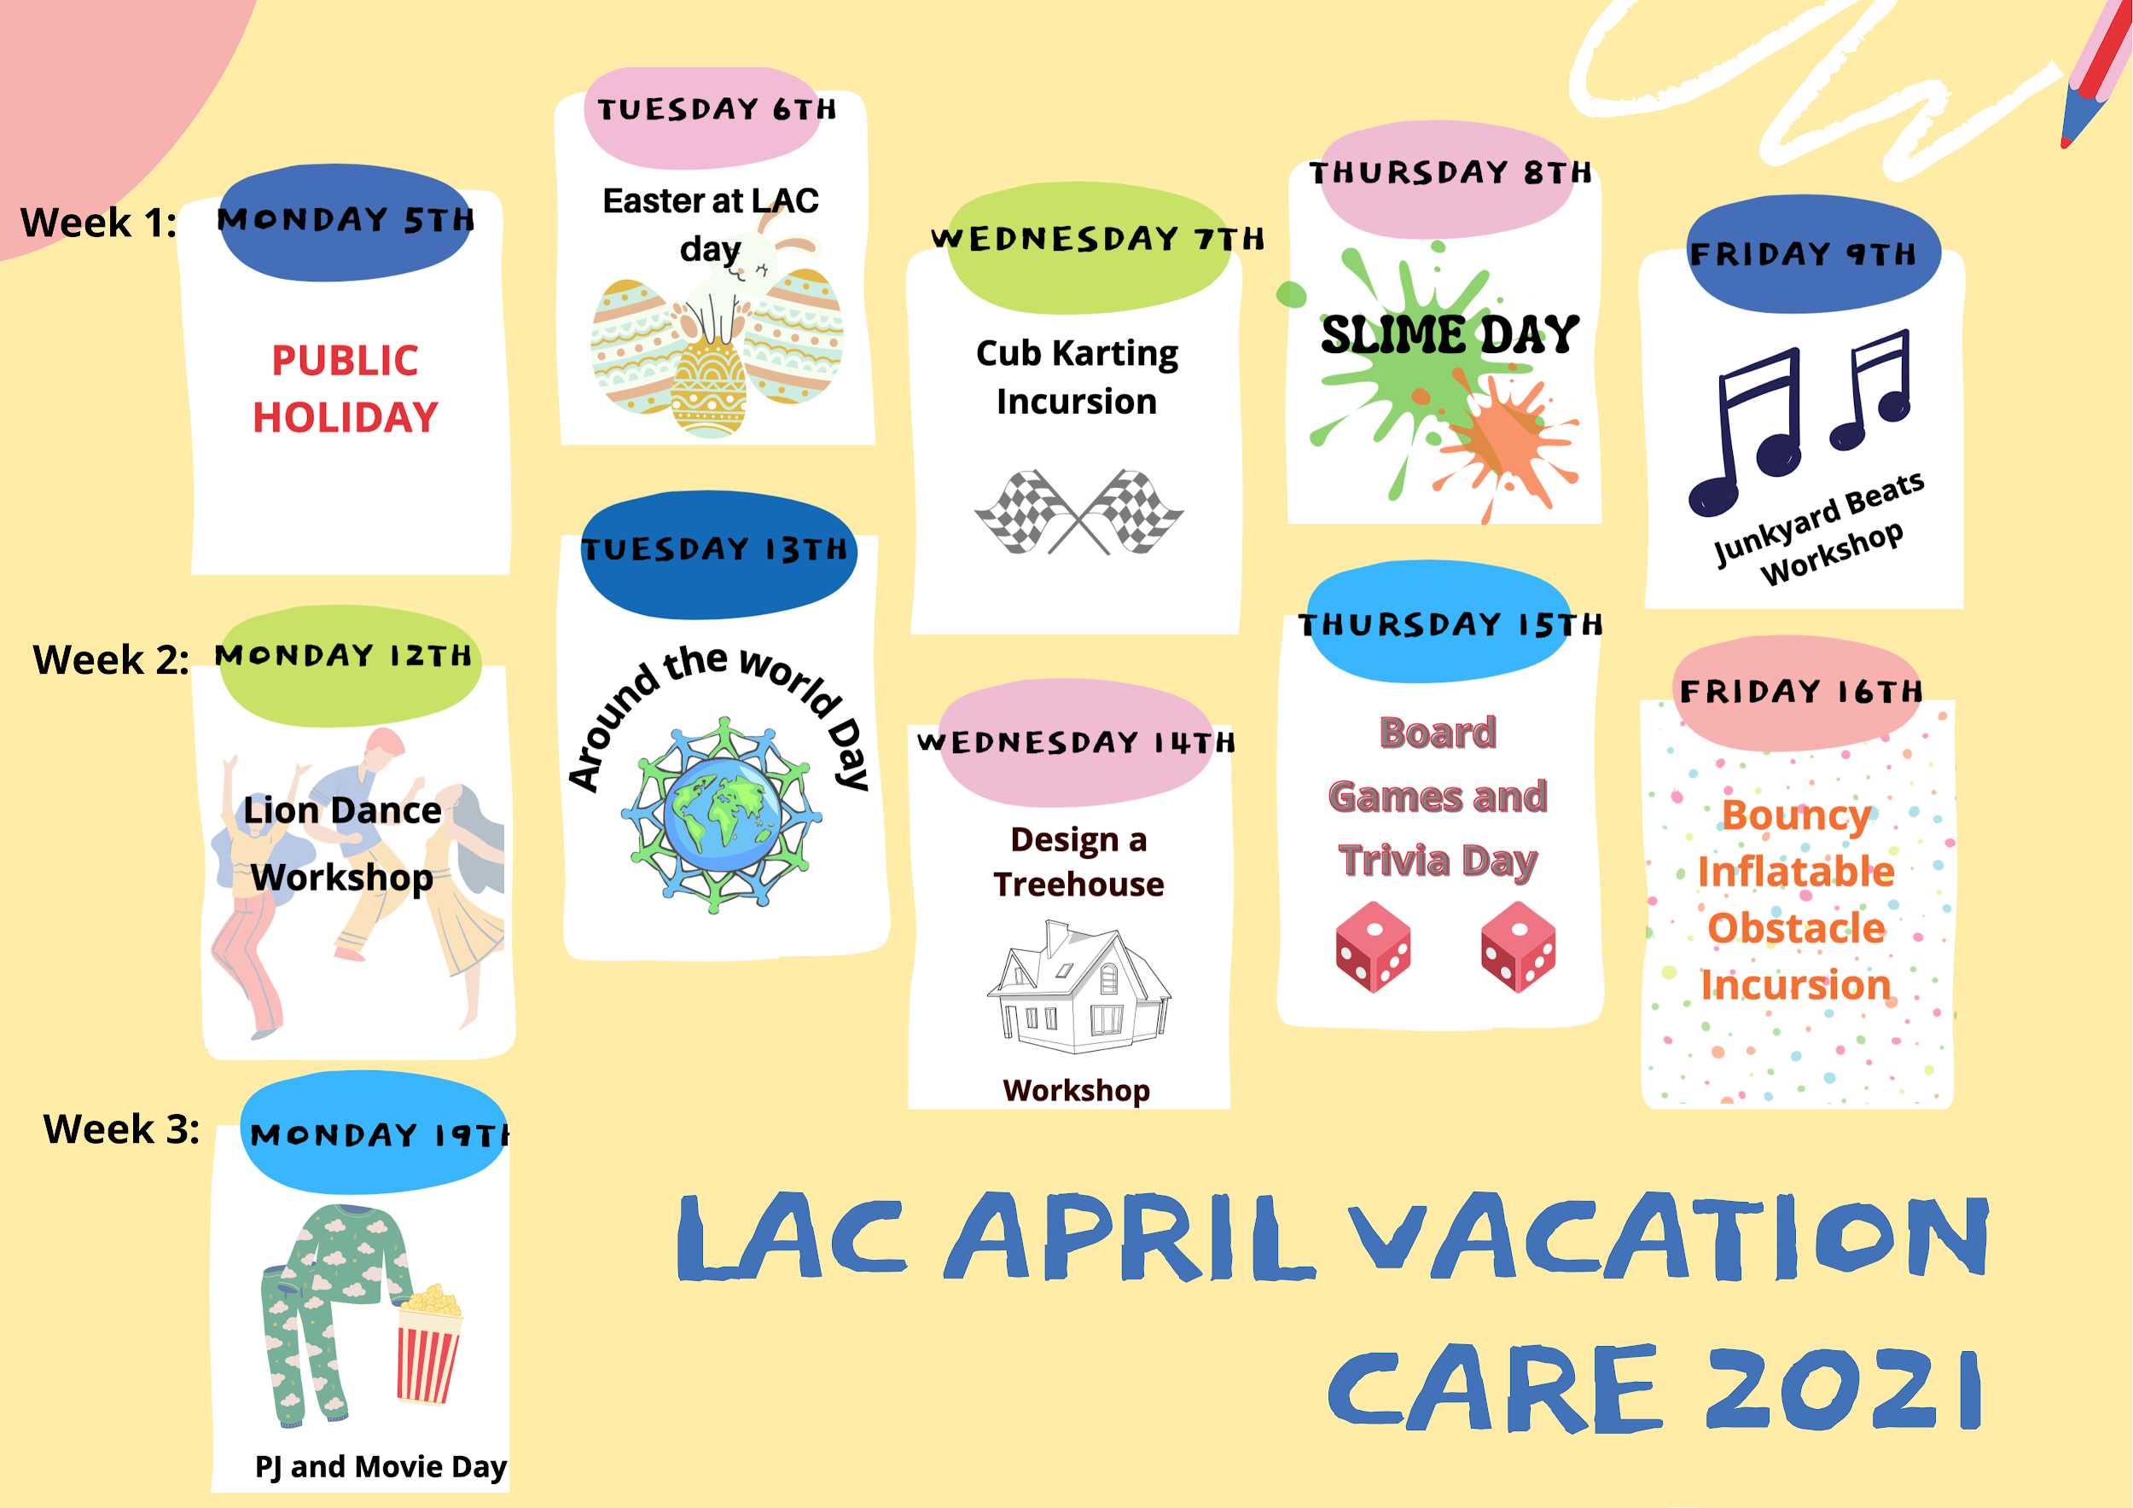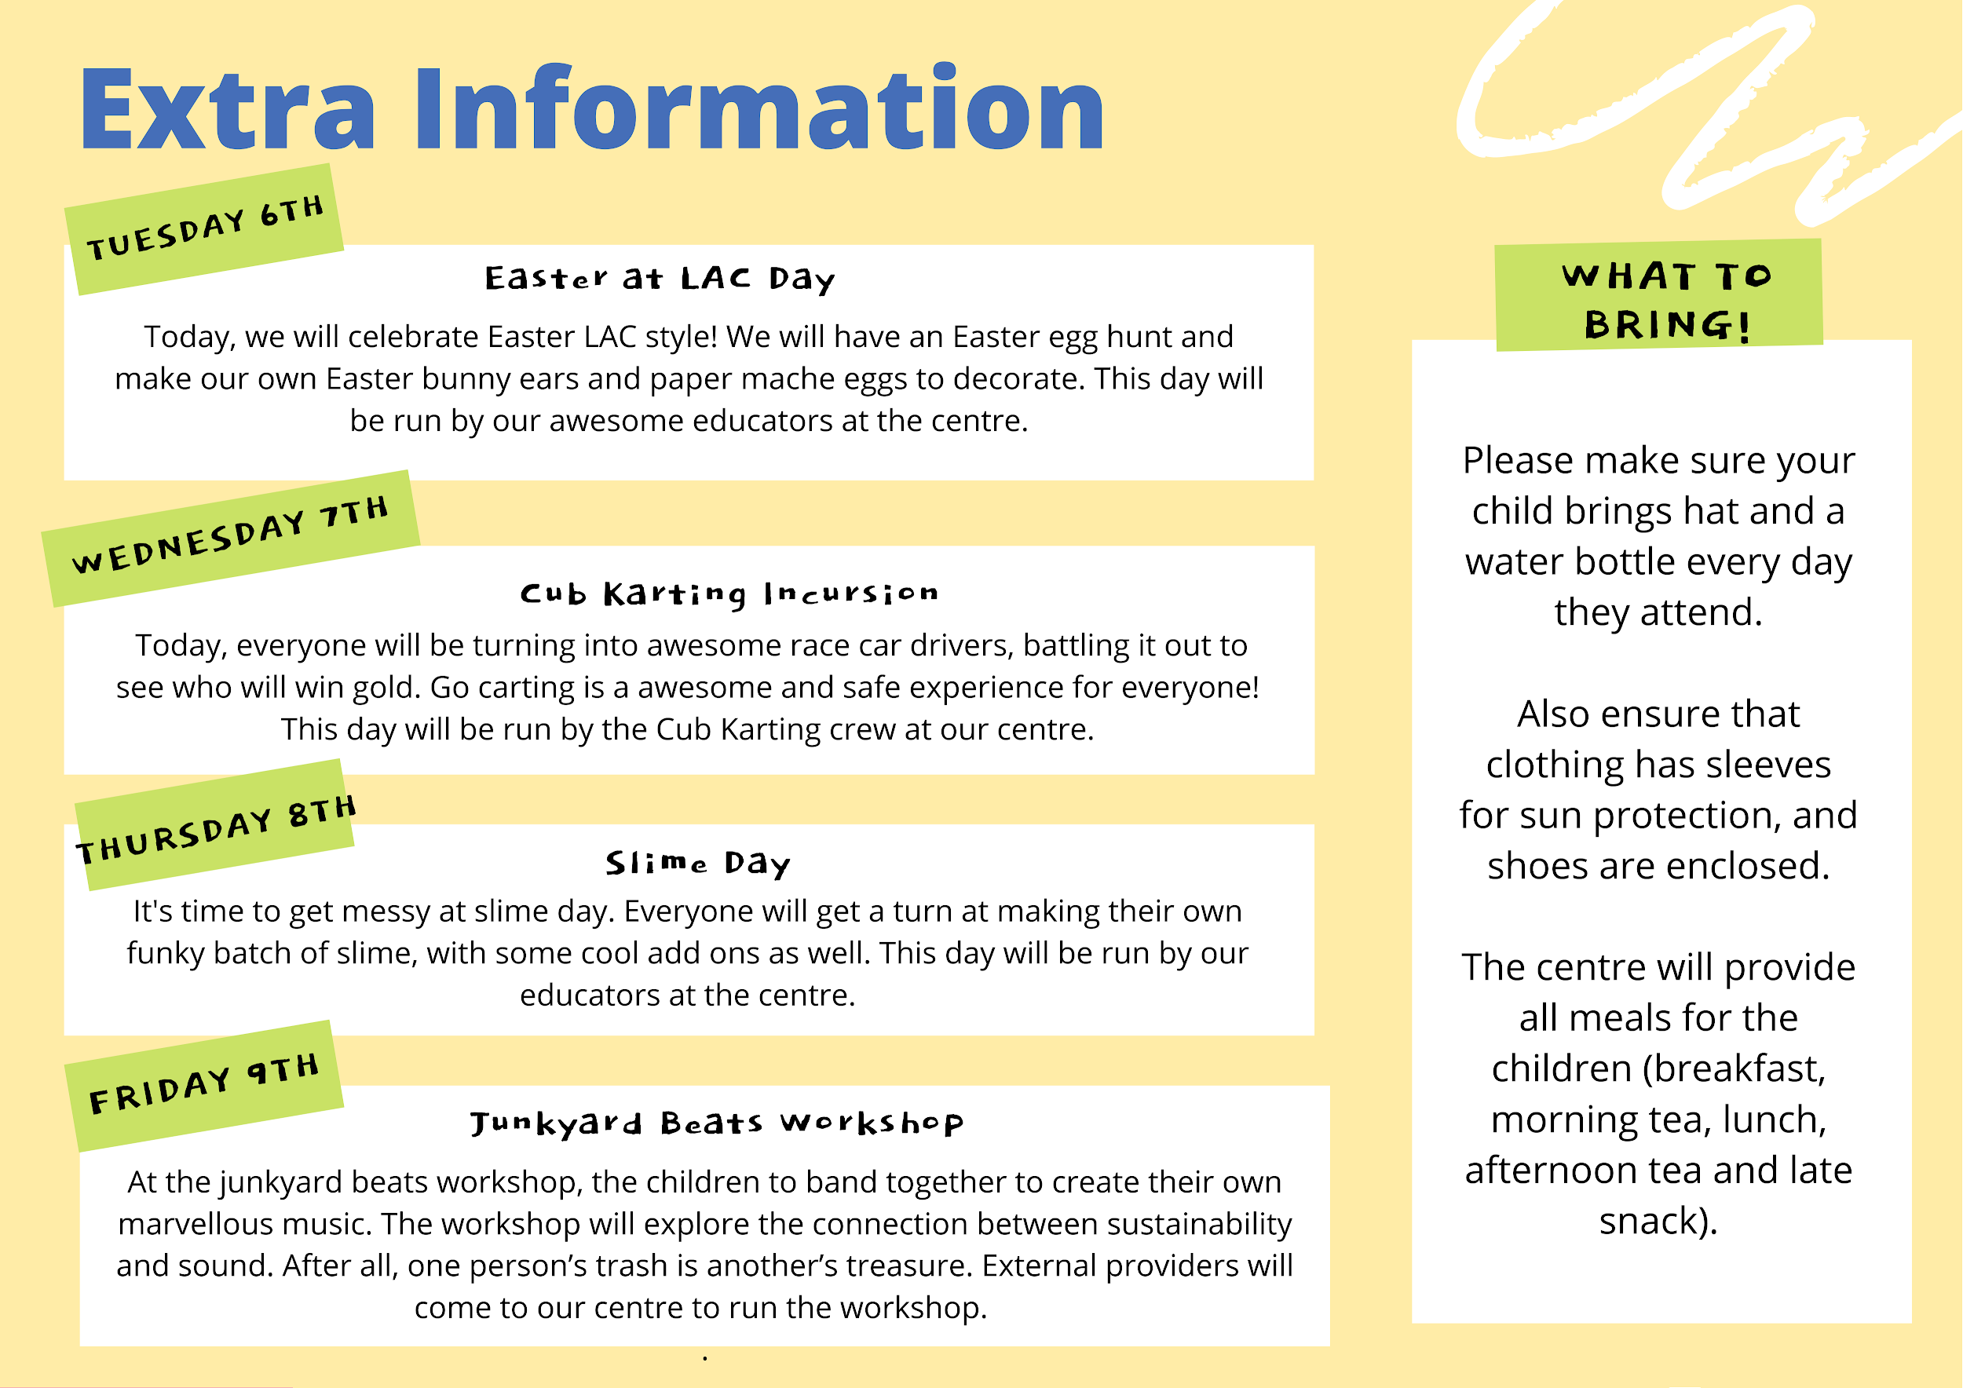

IMPORTANT INFORMATION (DETACH AND KEEP)

OPERATING TIMES
The centre will be open from 7.15am to 6.00pm each day.

On excursion days, all children must be at the Centre by 8:30AM. If your child is not signed in by the time the bus departs, your child will not attend the excursion. As only one program will be run each day, if an excursion is programmed, there are no alternative activities provided. All staff working on the excursion day will attend excursions and the LAC building will be closed on departure of the children and re-opened when they return.

ELECTRONIC EQUIPMENT AND DEVICES
Children are not allowed to bring electronic devices to LAC. Staff at LAC will take no responsibility for loss or damage to electronic equipment brought into the centre by the children.

SUN SAFETY
- Please make sure that your child comes to vacation care with sunscreen applied or help yourself to the bottle on the sign in desk.
- Your child must bring a hat. Children without an appropriate hat will not be allowed to participate in outdoor activities.

FEES
- Incursion days: $70 per day
- Excursion days: $90-$100 per day
- Full payment is required for booking to be confirmed.
- All CCS repayments will be credited into Term 2 fees.

My child/ren is currently enrolled at the service

My child/ren is not currently enrolled at the service (please complete an enrolment form)

 | Name | Age | D.O.B. | Allergies/medication/ special requirements
Child 1 (C1)
Child 2 (C2)
Child 3 (C3)

 |  | Mon 5th |  | Tues 6th |  | Wed 7th |  | Thurs 7^{8h} |  | Fri 9th
Activity |  | Public Holiday |  | Easter at LAC Day |  | Cub Karting Incursion |  | Slime Day |  | Junkyard Beats
Cost |  |  |  | $70 |  | $70 |  | $70 |  | $70
Child 1
Child 2
Child 3
 |  | Mon 12th |  | Tues 13th |  | Wed 14th |  | Thurs 15th |  | Fri 16th |  | Mon 19th
Activity |  | Lion Dance Workshop |  | Around the World Day |  | Design a Treehouse Workshop |  | Board Games and Trivia Day |  | Bouncy Inflatable Obstacle Incursion |  | PJ and Movie Day
Cost |  | $70 |  | $70 |  | $70 |  | $70 |  | $70 |  | $70
Child 1
Child 2
Child 3
All CCS entitlements will be credited into Term 2

Parent/Guardian Contact

Name: ___________________________ Email: ______________________________
Phone: ______________________
Vacation Care 2021 Terms & Conditions

I understand that:

- Fees are payable in advance in order to confirm position and booking.
- Once vacation care is confirmed, fees are not refundable.
- I understand that if my child/children are sick, fees are non-refundable.
- It is a legal requirement that a parent/guardian or other authorized person signs my child/children in and out of the service every day.
- If any unavoidable late change to the program occurs, a similar excursion/incursion will be substituted, and parents will be notified as soon as possible.
- This is a NUT FREE Centre - all and any food brought to the Centre must be nut free.
- Parents are required to notify the Centre of any allergies their child may have.
- Parents are responsible for updating all parent contact and emergency contact details including authorised pick up persons.
- Staff can only administer medications with the written permission from a parent/guardian. Parents requiring staff to administer medication must complete a Medication Authority form (included in the Centre enrolment form).
- Children are advised not to bring valuable items to the Centre.
- Children are not permitted to bring mobile phones, game boys, electronic equipment etc to the Centre. The Centre/staff cannot take responsibility for these items, especially on excursions. All personal items must be labeled.
- Centre and vacation care rules are established for the safety and enjoyment of all children. Children are expected to respect and follow these rules. Breaches of these rules will result in children being excluded from activities or, following consultation between Centre staff and parents, the rest of the program. Any critical incidents will result in immediate exclusion from the service.
- LAC closes at 6.00pm and late fees will be charged in accordance with LAC late fee policy.
- I agree to my child/children travelling with staff via public transport, chartered bus, car and walking where appropriate as part of the vacation care excursion program.
- I acknowledge that G and PG rated movies, DVD’s and games may be shown at the Centre where and when appropriate.
Parent/Guardian name: _____________________________ Date: _____________________
Signed: _________________________

